**Project Report On**

**Development of a Battery Health Monitoring System**

*Submitted*

*In partial fulfillment*

*For the award of the Degree of*

**PG-Diploma in Embedded Systems and Design**

**(PG-DESD)**

**C-DAC, ACTS (Pune)**

|  |  |  |
| --- | --- | --- |
| Guided by | Name | PRN |
| Mr. Shripad  Deshpande | Aditya Pal | 240340130003 |
| Akansha Prasad | 240340130005 |
|  | Labade Rahul Dnyaneshwar | 240340130027 |
|  | Shubham Pawar | 240340130046 |
|  |  |  |

**Centre for Development of Advanced Computing(C-DAC), ACTS (Pune- 411008)**

# Acknowledgment

This is to acknowledge our indebtedness to our Project Guide, **Mr. Shripad Deshpande C**-DAC ACTS, Pune for his constant guidance and helpful suggestions for preparing this project **Battery Health Monitoring System.** We express our deep gratitude towards him for the inspiration, personal involvement, and constructive criticism he provided us with and the technical guidance during this project.

We take this opportunity to thank the Head of the department, **Mr. Gaur Sunder,** for providing us with such a great infrastructure and environment for our overall development.

We sincerely thank **Ms. Namrata Ailawar**, Process Owner, for her kind cooperation and extendible support towards the completion of our project.

We are pleased to express sincere and deep gratitude towards **Mrs. Risha P R (Program Head)** and **Mrs. Srujana Bhamidi** (Course Coordinator, PG-DESD) for their valuable guidance and constant support throughout this work and help to pursue additional studies.

Also, our warm thanks to **C-DAC ACTS Pune**, which provided us with this opportunity to carry out, this prestigious Project and enhance our learning in various technical fields.

|  |  |
| --- | --- |
| Name | PRN |
| Aditya Pal | 240340130003 |
| Akansha Prasad | 240340130005 |
| Labade Rahul Dnyaneshwar | 240340130027 |
| Shubham Pawar | 240340130046 |
|  |  |

# Abstract

The electric vehicle (EV) revolution hinges on public understanding and acceptance. However, complex data and technical jargon presented by traditional Battery Health Monitoring System (BHMS) often confuse and hesitate consumers. This project tackles this challenge by developing an innovative EV BHMS dashboard designed specifically for the public.

Our dashboard bridges this gap by providing clear, understandable, and actionable insights into battery health, empowering consumers to:

* *Demystify EV battery data:* Visualize and comprehend key parameters like state of charge, health, and degradation in an intuitive and engaging format.
* *Gain confidence in EV ownership:* Proactively monitor battery performance, identify potential issues early, and make informed decisions about charging and maintenance.
* *Optimize EV usage:* Understand how driving habits and environmental factors impact battery life, enabling them to maximize range and efficiency.

This project goes beyond existing solutions by:

* *Prioritizing user understanding:* Focuses on clear communication and intuitive design, making complex data accessible to everyone.
* *Broadening EV acceptance:* Empowers consumers with the knowledge and confidence to embrace EV technology, accelerating its mainstream adoption.
* *Promoting sustainable practices:* Encourages informed EV usage and responsible charging habits, contributing to a greener future.

# Table of Contents

Acknowledgment 2

Abstract 3

Introduction 5

* 1. Introduction 5
  2. Objective 6

Literature Review 7

Methodology and Techniques 9

* 1. Block Diagram 9
  2. Hardware used 9
  3. Software used 10
  4. Protocols used 11

Implementation 18

* 1. Battery Health Monitoring System (BHMS) 18
  2. CAN Transmission 18
  3. Raspberry pi Interface 20
  4. Sending data to Things Speak 21

Result 22

Conclusions 23

Future Scope 24

References 25

**Chapter 1**

# Introduction

## Introduction

The rising tide of electric vehicles (EVs) in India holds immense promise for a cleaner future. However, a critical barrier remains complex dashboards drowning in technical jargon. These interfaces leave potential EV owners feeling bewildered and hesitant, creating a chasm between aspiration and action.

Imagine effortlessly understanding your EV's health and performance, replacing confusion with confidence. Our project addresses this challenge by developing a revolutionary EV dashboard designed for the Indian market.

Think beyond puzzling over technical terms. Our dashboard translates complex data into easy-to-understand information you can use. See your battery's health with a user-friendly graphical representation of data.

Our dashboard goes beyond user-friendliness, empowering you to:

* + - Confidently Manage Your EV: Make informed decisions regarding charging strategies, maintenance schedules, and battery optimization, maximizing your electric journey.
    - Embrace Sustainability: Understand how your driving habits and charging choices impact the environment, promoting eco-conscious practices.
    - Become an EV Champion: Be part of the green revolution, equipped with the knowledge and confidence to navigate the exciting world of EVs.

This project transcends technology, focusing on bridging the gap between aspiration and reality. We envision a future where every Indian driver can confidently join the EV revolution, empowered by a clear, intuitive dashboard.

Stay tuned as we unveil our innovative solution, designed to pave the way for a more informed, sustainable future of Indian mobility.

## Objective

This project aims to accelerate EV adoption in India by tackling a key challenge: complex dashboards filled with technical jargon. We're developing a user-friendly dashboard that transforms confusing data into clear, actionable insights presented in simple language.

Imagine understanding your battery health with engaging visuals, optimizing range with personalized tips, and making eco-conscious charging choices - all through our intuitive interface.

By empowering users with knowledge and encouraging sustainable practices, we pave the way for a confident and greener future of electric mobility in India.

**Chapter 2**

# Literature Review

1. S. Gopiya Naik et.al (2022) An electric car will have a system called Battery Monitoring and Control system placed in it. This system will talk about voltage and current and degree of hotness of the battery, as well as look for any indicators of a potential fire. This system is made up of both its hardware and its software. The key elements that constitute the battery monitoring system that is the subject of this discussion are the monitoring device itself as well as the user interface that is provided for the system. The system that is being presented monitors in real-time an indicator of the battery's voltage, current, and remaining charge capacity. Appropriate management actions are triggered as a result of this monitoring, which ensures that the battery is maintained in optimal condition.
2. A new system for monitoring electric vehicle batteries is presented. It uses sensors, a microcontroller, and an Android app to track voltage, current, temperature, and even fire risk. This low-cost system displays real-time data and can trigger safety measures if needed. It includes data acquisition, an Android interface, and server storage for future analysis. This research paves the way for a practical and affordable battery monitoring solution for electric vehicles
3. Lithium-ion batteries are driving innovation in various sectors, but accurate measurement of their charge and health (SOC & SOH) is crucial. This article reviews the latest algorithms for estimating SOC and SOH, highlighting their approaches, advantages, limitations, and potential improvements. Understanding these methods is key for optimal battery management, maximizing lifespan, and preventing failures. This analysis aims to guide future research and development in this critical field for technological advancement.
4. This paper presents an IoT-based battery monitoring system for EVs, addressing limited range and safety issues. It surpasses existing in-vehicle alert

systems by utilizing the internet to offer real-time battery status to both users and manufacturers. This enables proactive maintenance and safety checks, potentially mitigating risks and preventing problems. Technical details of the system design, implementation, and testing are provided, alongside a discussion of future directions for this impactful technology.

1. This paper explores leveraging the Internet of Things (IoT) to monitor electric vehicle battery performance. Recognizing the vehicle's dependence on battery health and potential for performance degradation, the authors propose an IoT-based monitoring system. This system comprises two key components: a monitoring device collecting battery data and a user interface for data visualization. Initial results demonstrate the system's capability to detect declining battery performance and alert users, enabling proactive maintenance and potentially extending battery lifespan
2. This paper addresses the crucial demand for precise battery state estimation in electric vehicles, focusing on lithium-ion batteries known for their compact size and high energy density. Three main estimation approaches are explored: electrochemical-based methods offer in-depth understanding but are computationally demanding; equivalent circuit model (ECM)-based methods provide faster results but may sacrifice accuracy; and data-driven approaches, relying on machine learning, offer flexibility but depend on data quality. The paper analyses research trends, limitations, and datasets, revealing the strengths and weaknesses of each method, and emphasizing challenges such as non-linear battery behavior and the importance of accurate state-of-charge and state-of- health information. The conclusion outlines future directions for research, aiming to enhance efficiency and reliability in electric vehicle battery state estimation.

**Chapter 3**

# Methodology and Techniques

## Block Diagram

Below is the basic block diagram of the system which will be implemented after the duration of this project.

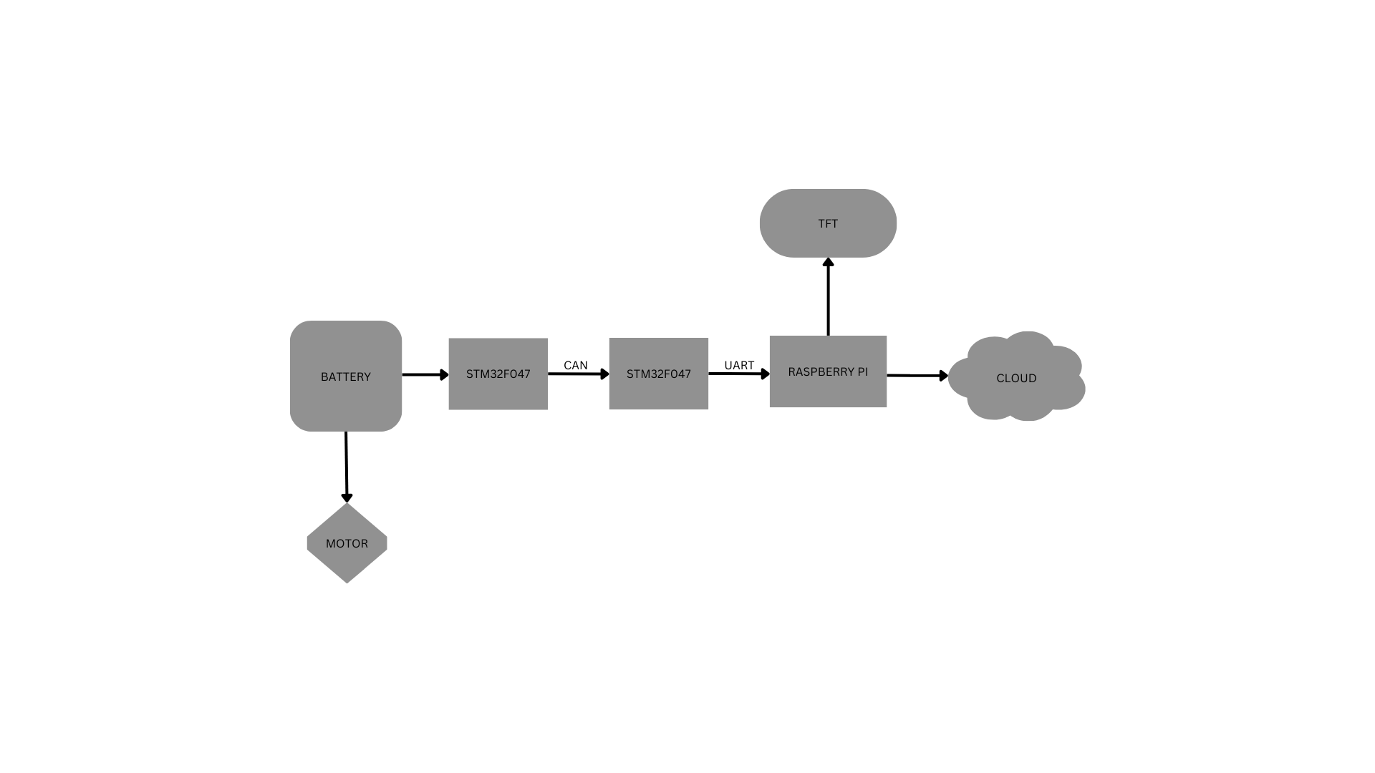

The goal is to minimize the data transfer length and time between the various modules of an Electric Vehicle (EV) to make the system as real-time as possible and to further better the prediction accuracy to serve the user's needs better.

## Hardware used

* + 1. STM32F407VGT – Is the main board used as a hub where all data comes together and is sent ahead to Raspberry pi 3b + to be sent to the cloud; although this board can be used at a maximum clock frequency of 168Mhz this is bottlenecked by the board from where we are receiving the data via the CAN bus.
    2. CAN Transceivers – The MCP2515 is an ISO-11898 compliant high-speed CAN (Controller Area Network) transceiver designed to interface between a CAN protocol controller and the physical bus. It supports operating speeds up to 1Mb/s.
    3. (STM32F407VGT). This board was chosen on the basis that it has an adequate amount of processing power while also supporting CAN with an inbuilt CAN controller.
    4. Battery – We are using a 2600mAh ICR-18650 3.7V Lithium-ion Battery.
    5. The Raspberry Pi 3 B+ - This is a versatile and popular single-board computer used for a variety of applications.We are using this for storing and computing the data and as well as for sending the data on the cloud.
    6. Voltage sensor -This sensor is used to monitor, calculate and determine the voltage supply. This sensor can determine the AC or DC voltage level. The input of this sensor can be the voltage whereas the output is the switches, analog voltage signal, a current signal, an audible signal, etc. Some sensors provide sine waveforms or pulse waveforms like output & others can generate outputs like AM (Amplitude Modulation), PWM (Pulse Width Modulation) or FM (Frequency Modulation). The measurement of these sensors can depend on the voltage divider.
    7. Current sensor – The Current Sensor ACS712 is used for current measurement.

The ACS712 is a fully integrated, hall effect-based linear current sensor with 2.1kVRMS voltage isolation and a integrated low-resistance current conductor. Technical terms aside, it’s simply put forth as a current sensor that uses its conductor to calculate and measure the amount of current applied.

The features of ACS712 include:

80kHz bandwidth

66 to 185 mV/A output sensitivity

Low-noise analog signal path

Device bandwidth is set via the new FILTER pin

1.2 mΩ internal conductor resistance

Total output error of 1.5% at TA = 25°C

Stable output offset voltage.

Near zero magnetic hysteresis

* + 1. Temperature Sensor LM35
* LM35 is a temperature measuring device having an analog output voltage proportional to the temperature.
* It provides output voltage in Centigrade (Celsius). It does not require any external calibration circuitry.
* The sensitivity of LM35 is 10 mV/degree Celsius. As temperature increases, output voltage also increases.

          E.g. 250 mV means 25°C.

* It is a 3-terminal sensor used to measure surrounding temperature ranging from -55 °C to 150 °C.
* LM35 gives temperature output which is more precise than thermistor output.

## Software used

* + 1. STM32 CUBE IDE – STM32CubeIDE is an integrated development environment (IDE) from STMicroelectronics tailored for STM32 microcontrollers.

## Protocols used

* + 1. UART – **U**ART stands for **Universal Asynchronous Receiver/Transmitter**. It's a simple, two-wire serial communication protocol commonly used for low-speed data transmission between devices. Here's a breakdown of its key aspects:

### Functionality:

* + - 1. UART converts parallel data (multiple bits sent simultaneously) into serial data (bits sent one after another) for transmission and vice versa for reception.
      2. It manages the start and stop bits of each data frame, ensuring clear boundaries between characters.
      3. Some UART implementations offer optional error- checking capabilities.

### Hardware:

1. Typically requires just two wires for data transmission (Rx and Tx) and a ground connection.
2. A UART chip or logic within a microcontroller handles the data conversion and protocol management.

### Data Transmission:

1. Asynchronous nature means no shared clock signal between devices. Both sides must agree on the bitrate (usually between 600 bps and 115,200 bps) for successful communication.
2. Each data byte is framed with start and stop bits, typically a single start bit (logic 0) and one or two stop bits (logic 1).

Some configurations include an optional parity bit for error detection.

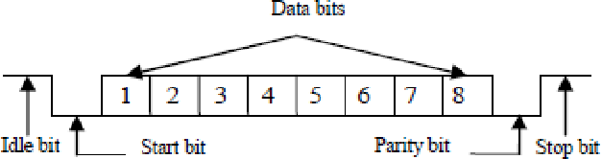

### Applications:

1. UART is widely used in embedded systems for communication with peripherals like sensors, displays, and debug consoles.
2. Common applications include configuring microcontrollers, interfacing with GPS modules, and serial communication over Bluetooth modules.

### Advantages:

1. Simple and low-cost implementation.
2. Easy to integrate with microcontrollers.
3. Suitable for low-speed, short-distance communication.

### Disadvantages:

1. Limited speed compared to other protocols like I2C or SPI.
2. No addressing capabilities, making it unsuitable for multi-device networks.
3. Prone to errors in noisy environments without robust

error checking.

* + 1. CAN –

**Bit Timing and Synchronization:** Each CAN bit has a specific duration defined by the "Bit Time." All nodes on the bus sample the signal at specific points within this bit time to identify dominant or recessive bits. Oscillator circuits maintain this timing accuracy.

**Error Detection and Correction:** CAN uses several mechanisms for error detection. **Cyclic Redundancy Check (CRC):** Each message includes a checksum to detect transmission errors. **Bit stuffing:** Ensures transitions in the signal for easier synchronization. **Error frames:** Nodes

can transmit error frames if they detect issues. CAN may offer automatic retransmission of messages with errors.

**CAN Frame Format:** A CAN message consists of:

* + - 1. **Arbitration field:** Used for message priority and bus access.
      2. **Control field:** Identifies frame type and data length.
      3. **Data field:** Carries actual information (up to 8 bytes in standard CAN, 64 bytes in CAN FD).
      4. **CRC field:** Ensures data integrity.
      5. **Acknowledgement field:** Nodes acknowledge receiving the message successfully.

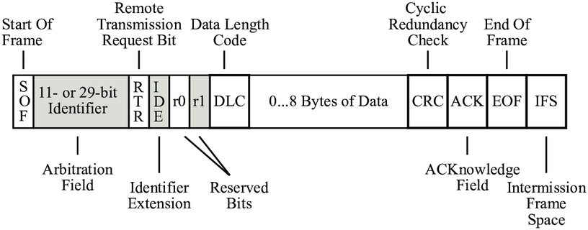

### Higher-level Protocols:

1. **CAN FD (Flexible Data Rate):** Extends standard CAN with higher bitrates (up to 15 Mbps) and larger data payloads (up to 64 bytes).
2. **J1939:** Used in heavy-duty vehicle applications, extending CAN with addressing capabilities and message filtering.

### Practical Applications: CAN Bus in specific industries:

* 1. **Transportation:** Engine, ABS, airbags, and infotainment systems in cars and aircraft.
  2. **Industrial automation:** Factory control systems, robotic equipment.
  3. **Medical devices:** Infusion pumps, and patient monitoring systems.
  4. **Building Automation:** HVAC systems, lighting control, security systems.

**Troubleshooting CAN Bus networks:** Common issues include wiring faults, node malfunctions, and software bugs. Tools like CAN analyzers help diagnose and resolve issues.

**Developing CAN Bus applications:** Tools like microcontrollers, CAN transceivers, and libraries (e.g., Socket, CAN) enable communication with CAN devices.

### Comparison with other communication protocols:

|  |  |  |  |  |
| --- | --- | --- | --- | --- |
| *Feat*ure | CAN | RS-232 | Ethernet | Wireless |
| Speed | Up to 1 Mbps (CAN FD: 15 Mbps) | Up to 115 kbps | Up to 1 Gbps | Variable |
| Cost | Low | Low | Moderate | Moderate |
| Comple xity | Moderate | Low | High | High |
| Reliabil  ity | High | High | Moderate | Moderate |
| Broadc  ast | Yes | No | Yes | Variable |
| Multi- master | Yes | No | Yes | Yes |
| Suitabl e for | Real-time control | Simple point-to-  point | High-speed data transfer | Flexible networking |

**Choosing CAN Bus:** Consider factors like speed requirements, network size, cost constraints, reliability needs, and real-time control demands.

**Chapter 4**

# Implementation

## Battery Health Monitoring System (BHMS)

A Battery Health Monitoring System or BHMS is a system that takes into consideration the Voltage, Current, and Temperature and gives insight into the battery health, and predicts the longevity/range of the battery/EV. We have used various sensors like the Voltage sensor and Current sensor (ACS712) and calculated factors like SOC and SOH which give the user actionable insights on when to charge and when to completely swap the battery.

This data is then sent to STM32F407VGT using CAN Transceivers.

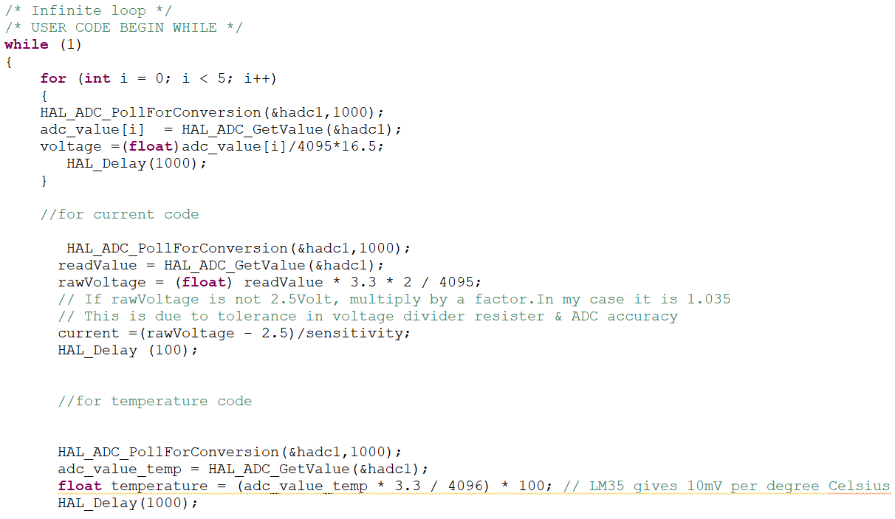

## CAN Transmission

CAN is used for data transmission in an EV working environment because of its robust nature against electrical interference and harsh operating conditions often encountered in vehicles.

We have used CAN to transmit data between first STM32F407VGT and second STM32F407VGT, which requires both sides to have the same clock frequencies, this has created a bottleneck of 72MHz clock frequency on the STMF4 board.

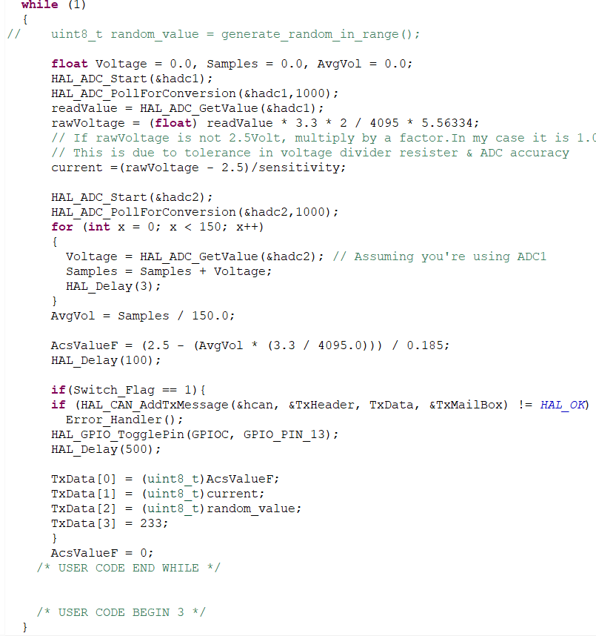

The above code is responsible for getting data from the sensors via the ADCs and then sending the data over CAN to STM32F4 from STM32F4

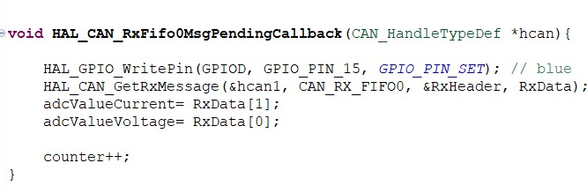

The above code is responsible for receiving data from the CAN bus, this is written in the callback as it is only called when the CAN bus generates an interrupt via the mailbox notification.

Thus, we have used the mailbox functionality here to inform the receiver end when it has received data on the can transceive

Sending data to Things Speak

To finally make a Dashboard we need to send the data to an IoT platform, we are using MQTT protocol via Raspberry Pi 3 B+, however, we need to first get data from STM32F4 to the Raspberry Pi 3 B+.

For this, we are using UART to connect the STM32F4 and Raspberry Pi 3 B+. Further, we send this data from the Raspberry Pi 3 B+ in JSON format to the cloud

Things Board IoT Cloud Platform using MQTT (Message Queuing Telemetry

Transport) protocol.

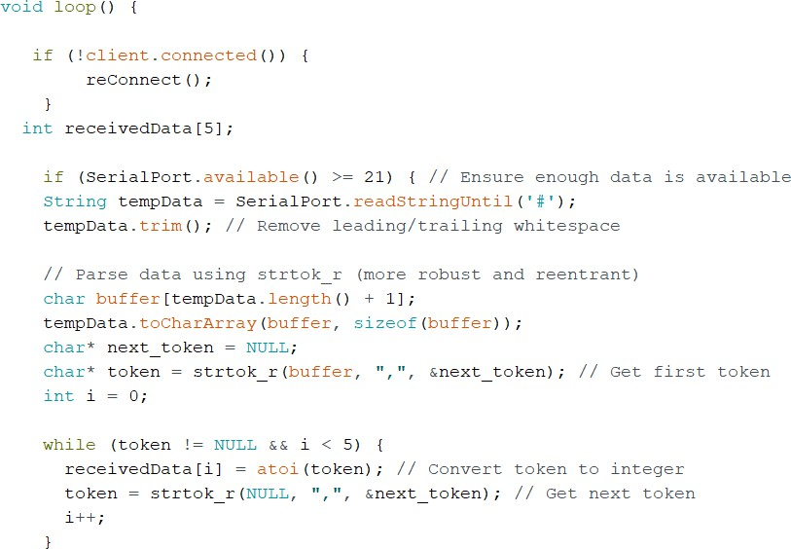

Code to parse the data in a meaningful manner for further operation by the Raspberry Pi 3 B+ after receiving it via UART from STM32F4

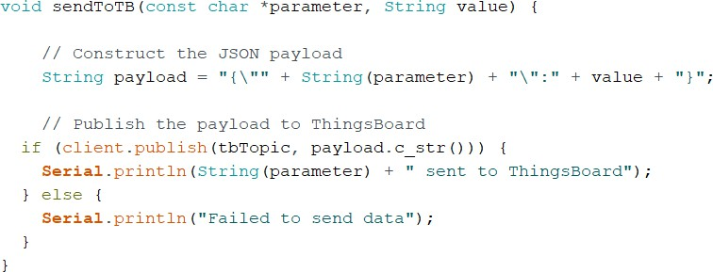

Function to create a JSON file of data to be sent to the cloud and send it using MQTT

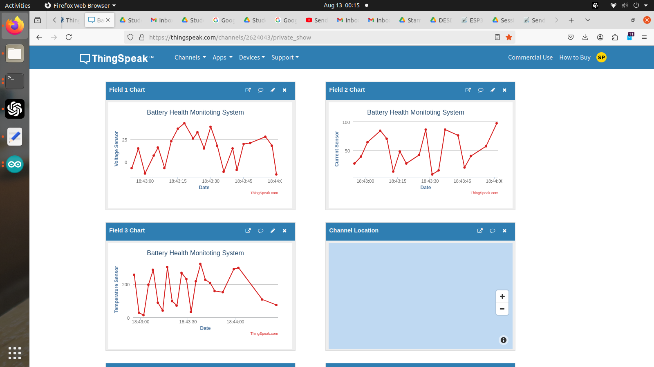

# Result

* A successful connection between boards was made using various communication protocols and were all integrated to work in harmony and provide a smooth user experience
* Even though the use of STM32F407 caused a bottleneck limiting all other CPUs connected to it via CAN to 72MHz, the entire functionality was optimized to work without a hitch.
* The dashboard was able to successfully show data giving actionable insights to the user regarding his EV without much of the technical jargon.

# Conclusions

* The dashboard created a great tool and has a good chance of increasing the rate at which EVs are adopted by the market.
* By implementing such a minimalist system EVs can be made more affordable thus widening the scope of the targeted audience.
* SOC and SOH of all the cells of the battery gives the a rough idea of condition of the battery.

# Future Scope

* + Currently due to there being only two ADCs on STM32F407VGT6 only Current and Voltage data are imported but by further multiplexing the ADC channels or by external multiplexing to get more data from the battery and process it for more in-depth analysis of battery health while charging and during EV running.
  + By implementing it with multiplexed ADCs and getting data about other parameters like Temperature and charge strength combined with running data from the encoder it may be possible to accurately predict the battery left taking into consideration these parameters.
  + Using these data via Artificial Intelligence we can predict the life span of a battery.
  + We can identify which cell of the battery are faulted.

# References

1. S. Malve, A. Nayak, R. Thape and G. T. Haldankar, "Real-time Battery Monitoring System for Solar Infrastructure," 2020 IEEE First International Conference on Smart Technologies for Power, Energy and Control (STPEC), Nagpur, India, 2020, pp. 1-5, doi: 10.1109/STPEC49749.2020.9297710.
2. S., Gopiya & Harmain, Chaithra & Sharif, Bhojaraj-Bhoomika. (2022). Battery Parameter Monitoring and Control System for Electric Vehicles. International Journal of Electrical and Electronics Engineering. 9. 1-6.
3. Dini, Pierpaolo & Colicelli, Antonio & Saponara, Sergio. (2024). Review on Modelling and SOC/SOH Estimation of Batteries for Automotive Applications. Batteries. 10. 34. 10.3390/batteries10010034.
4. Helmy, Mohd & Abd Wahab, Mohd Helmy & Imanina, Nur & Anuar, Mohamad & Ambar, Radzi & Baharum, Aslina & Shanta, Shanoor & Sulaiman, Mohd & Sanim, Shukor & Hanafi, Hafizul. (2018). IoT-Based Battery Monitoring System for Electric Vehicle. International Journal of Engineering & Technology. 7. 505-510. 10.14419/ijet. v7i4.31.25472.
5. Helmy, Mohd & Abd Wahab, Mohd Helmy & Imanina, Nur & Anuar, Mohamad & Ambar, Radzi & Baharum, Aslina & Shanta, Shanoor & Sulaiman, Mohd & Sanim, Shukor & Hanafi, Hafizul. (2018). IoT-Based Battery Monitoring System for Electric Vehicle. International Journal of Engineering & Technology. 7. 505-510. 10.14419/ijet. v7i4.31.25472.
6. Swarnkar, R.; Ramachandran, H.; Ali, S.H.M.; Jabbar, R. A Systematic Literature Review of State of Health and State of Charge Estimation Methods for Batteries Used in Electric Vehicle Applications. World Electr. Veh. J. 2023, 14, 247. <https://doi.org/10.3390/wevj14090247>.
7. STMicroelectronics, “User manual Discovery kit with STM32F407VG MCU”, Oct 2020.
8. STMicroelectronics, “STM32F103x8, Datasheet”, Sept 2023.
9. Espressif Systems, “ESP32Series Datasheet”, Oct 2016.
10. Microchip Technology Inc, “MCP2551 High-Speed CAN Transceiver”, Dec 2023.
11. “Datasheet Bluetooth to Serial Port Module HC05”, Oct 2022
12. Allegro Microsystems. “ACS712, Hall-Effect-Based Linear current sensor”, Feb 2023.
13. Fairchild Semiconductor, “LM7806 6V DC / AC, Three Terminal Voltage, Regulator Power”, Apr 1999.